**THE WHITEHAVEN BEACH**

**Whitehaven Beach** is on [Whitsunday Island](https://en.wikipedia.org/wiki/Whitsunday_Island), [Queensland](https://en.wikipedia.org/wiki/Queensland), [Australia](https://en.wikipedia.org/wiki/Australia). The island is accessible by boat, seaplane & helicopter from Airlie Beach, as well as [Hamilton Island](https://en.wikipedia.org/wiki/Hamilton_Island_(Queensland)). It lies across from Stockyard Beach, better known as [Chalkie's Beach](https://en.wikipedia.org/wiki/Chalkie%27s_Beach" \o "Chalkie's Beach), on Haslewood Island. The seven kilometres beach is known for its crystal white silica sands and [turquoise](https://en.wikipedia.org/wiki/Turquoise_(color)) coloured waters. The beach has tour barbeque and camping facilities.

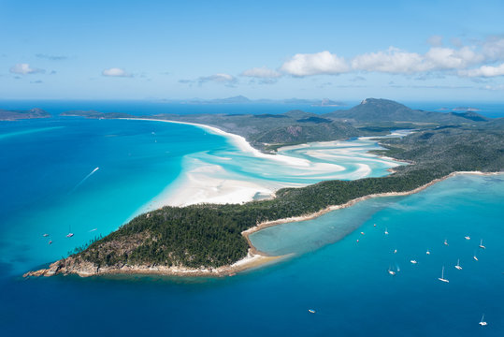

Whitehaven Beach is known for its bright white sands, which consist of 98% pure [silica](https://en.wikipedia.org/wiki/Silica). Local rocks do not contain silica so it has been suggested that the sands were brought to the beach by prevailing sea currents over millions of years. Tourists and locals visit Whitehaven Beach to swim and take in the bright white sand.